

# Faculty of Science School of Computer Science

**2020-2021**

**A PROJECT REPORT**

**ON NOTERA BY**

# Mrudula Gadre Kemmy Kalaria

**Someshwar Sharma Shasuat Thackar**

**IN PARTIAL FULFILLMENT OF MASTERS OF COMPUTER APPLICATIONS**

**Dr. Vishwanath Karad MIT- World Peace University**



**Faculty of Science School of Computer Science**

**CERTIFICATE**

This is to certify that **Miss Kemmy Kalaria ,** Student of MCA (Science) Semester IV has successfully completed a mini project in partial fulfilment of MCA (Science) Degree under Dr. Vishwanath Karad MIT-World Peace University, for the academic year 2020-2021.

(Project Guide) Head of School

## Prof. SWAPNIL SIR Dr. C. H.Patil

Associate Dean Seal

## Dr. Shubhalaxmi Joshi

Date:

Examiners: 1.

2.



# Faculty of Science School of Computer Science

**CERTIFICATE**

This is to certify that **Miss Mrudula Gadre** Student of MCA (Science) Semester IV has successfully completed a mini project in partial fulfilment of MCA (Science) Degree under Dr. Vishwanath Karad MIT-World Peace University, for the academic year 2020-2021.

(Project Guide) Head of School

## Prof. Swapnil Goje Dr. C. H.Patil

Associate Dean Seal

## Dr. Shubhalaxmi Joshi

Date:

Examiners: 1.

2.



# Faculty of Science School of Computer Science

**CERTIFICATE**

This is to certify that **Mr. Someshwar Sharma ,** Student of MCA (Science) Semester IV has successfully completed a mini project in partial fulfilment of MCA (Science) Degree under Dr. Vishwanath Karad MIT-World Peace University, for the academic year 2020-2021.

(Project Guide) Head of School

## Prof. Swapnil Goje Dr. C. H. Patil

Associate Dean Seal

## Dr. Shubhalaxmi Joshi

Date:

Examiners: 1.

2.



# Faculty of Science School of Computer Science

**CERTIFICATE**

This is to certify that **Mr. Shasuat Thackar ,** Student of MCA (Science) Semester IV has successfully completed a mini project in partial fulfilment of MCA (Science) Degree under Dr. Vishwanath Karad MIT-World Peace University, for the academic year 2020-2021.

(Project Guide) Head of School

## Prof. SWAPNIL SIR Dr. C. H.Patil

Associate Dean Seal

## Dr. Shubhalaxmi Joshi

Date:

Examiners: 1.

2.

**ACKNOWLEDGEMENT**

I wish to express my deep sense of gratitude and honour towards the faculty for giving us a chance and platform to work on such projects.

I also wish to thank everyone in the organization that helped me during project development time to time. I also express my honour and gratitude to **Prof.Swapnil Goje** and constant encouragement for completing my project work successfully.

I also want to thank **Dr. C. H. Patil** for constant encouragement and help for completing my project work successfully.

Student Signature

**INDEX**

|  |  |  |
| --- | --- | --- |
| **Sr. No.** | **Contents** | **Page No.** |
| **Chapter 1** | **INTRODUCTION** |  |
| 1.1Problem Statement | 8 |
| 1.2Existing System | 8 |
| 1.3Need of New System | 8 |
| **Chapter 2** | **PROPOSED SYSTEM** |  |
| 2.1 Proposed System | 9 |
| 2.2 Objectives of System | 9 |
| 2.3 User Requirements | 10 |
| **Chapter 3** | **ANALYSIS AND DESIGN** |  |
| 3.1 Entity Relationship Diagram | 12 |
| 3.2 UML Diagram | 13 |
| 3.3 Screen Shots | 19 |
| **Chapter 4** | **TESTING** |  |
| 4.1 Testing & Characteristics of Testing | 28 |
| 4.2 Test Cases | 28 |
| **Chapter 5** | **CONCLUSION** |  |
| 5.1 Limitations & Drawbacks | 28 |
| 5.2 Future Enhancement | 28 |
| 5.3 Conclusion | 28 |
| 5.4 References & Bibliography | 28 |

**INTRODUCTION**

Notera is a web-based system used for planning our daily events. Notera helps us manage our project or everyday tasks in an effective and orderly manner. It divides the tasks into three parts : To do , Doing and Done. Multiple projects can be created by a single user.

## PROBLEM SATEMENT

The idea is to develop a web Application to organize daily task between team members For the efficient and Up To Date transfer of information between all team members to avoid work repetitions and omitted works and providing a way in which Leader can create task and assign them to members and generate a report on daily basis.

The system will help leader and member to keep them Updated with tasks and activities.

## EXISTING SYSTEM

In the existing manual system, all the documents are prepared manually by writing in books which takes a longer time and is not so reliable. There are many drawbacks of the existing system such as requirement of large number of human resource and papers along with higher chance of losing data and tearing books. To overcome these drawbacks, a computerized management system is required.

**NEED OF SYSTEM**

Considering the existing system the system is working on papers and pen so with this system we can easily manage the task and project and can also share the file with team members .

We can easily take a backup of projects or work done and can easily reuse it anytime , we can takes notes from previous projects for more development and efficiency .

Managing project with multiple people will can more easier, giving task and and getting reports will be more efficient and time saving

# PROPOSED SYSTEM

## Scope

As this is a generic software it can be used by a wide variety of outlets to automate the process of manually maintaining the information and records related.

## Goal

The main goal of the project is manage our project or everyday tasks in an effective and orderly manner.

**Advantages Of Proposed System**

The system is very simple in design and to implement. The system requires very low system resources and the system will work in almost all configurations.

* + Minimize manual data entry.
  + User friendly and interactive.
  + Minimum time required

## SOFTWARE (LANGUAGE)

Platform : Browser.

Font end : JavaScript , html, css.

Back end : Php.

Database : MySql.

# REQUIREMENT ANALYSIS

Today life is very fast and work with the computer is speedy. The existing system was manually on paper. So it is time consuming as compared with our system a man cannot do work as fast as computer.

In existing system paper work is more where as in our system on computer, so most of the work is done on computer and mobile it provide facilities to change if any mistake occurred.

So we can say that in existing system paper work is more. All the information is on paper in existing system so, there are possibilities of loss, theft, burning and damaging data on paper. Where as in computer system all data are saved and backup of data is also taken if user want. So there are less chances of data loss then the existing system. Existing system is inconvenient for user because it cannot give fast and proper information in proper time and it take long time to give information to the user. In our system the information is generated very quickly and prepared accordingly to the user request. Computer system provide very easy and flexible report generation whereas report generation on paper is time consuming and it is difficult to change if any mistake occurred in between while in computerized system reports are generated automatically.

## MODULES USED

Each module has certain specific functions and all the modules are interlinked to each other.The proposed Notera application modules are:

1. **Login module** : The Login Module is a portal module that allows users to type a user name and password to log in.
2. **Chat module** : The Chat Module is allows member to chat with each other in group.
3. **Edit Profile** : In edit profile user can change the details and update there details.

**PAGE DESCRIPTION**

## Home Page-

It is the first page you visit after logging in to the system. It contains link to all other pages and also basic information of the team and other ongoing project.

## Task Page-

This is the main page where all the work will be done. New project can be created on this page or a pre-created project can be edited. Each project will have two visibility stages : Public or private. If the project is private, the project will only be visible to the creator and if the project is public it will be visible to all the team members tagged in it.

## Chatbox Page –

Here, all the members will be able to connect and chat with each other. In this chatbox page user can create group .User can also see the other members are online or offline.

## Profile Page-

It will show all the information of the user which he/she has entered while signing up for the website. It will also show all the private and public projects of the user.

**USER OF THE SYSTEM**

There are mainly two types of users:

* Leader/Creator-

Leader is the one who creates the project and adds the team members.

* Team Members-

Team members are the one who are invited or added by the creator. Team members have limited accessibility in the project. Lists or tasks can’t be edited by a team member.

# ANALYSIS AND DESIGN

**Entity Relationship Diagram**

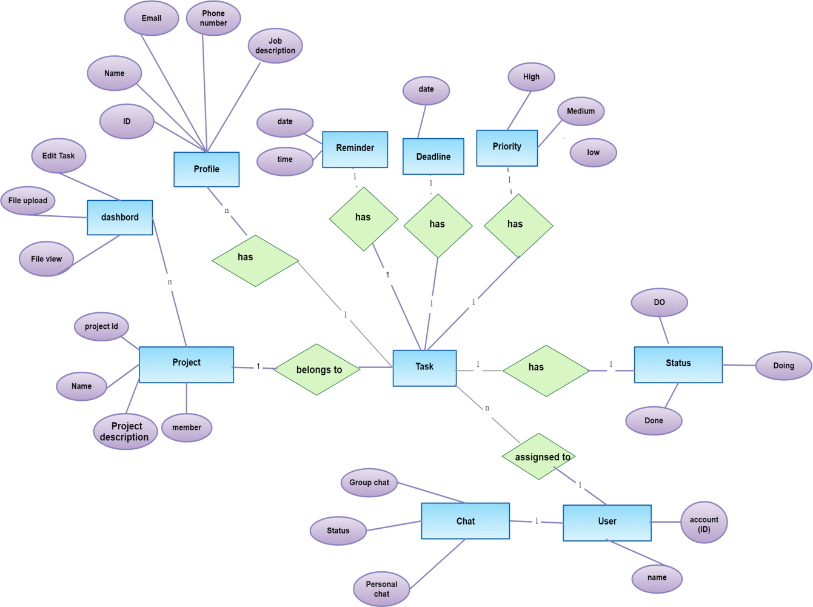

**UML DIAGRAM**

**ACTIVITY DIAGRAM**

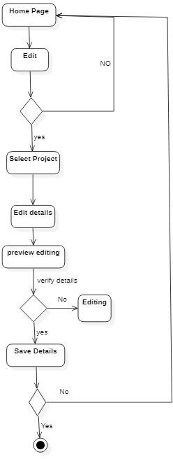

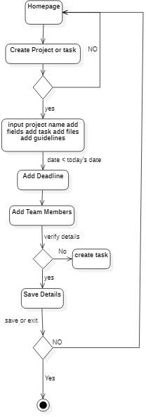

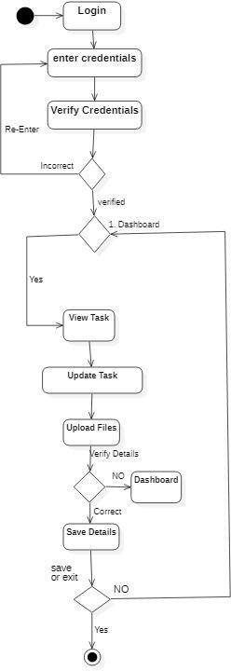

**DATA FLOW DIAGRAM**

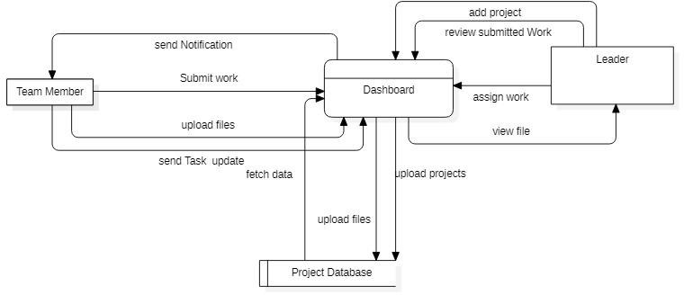

**Level 2 DFD**

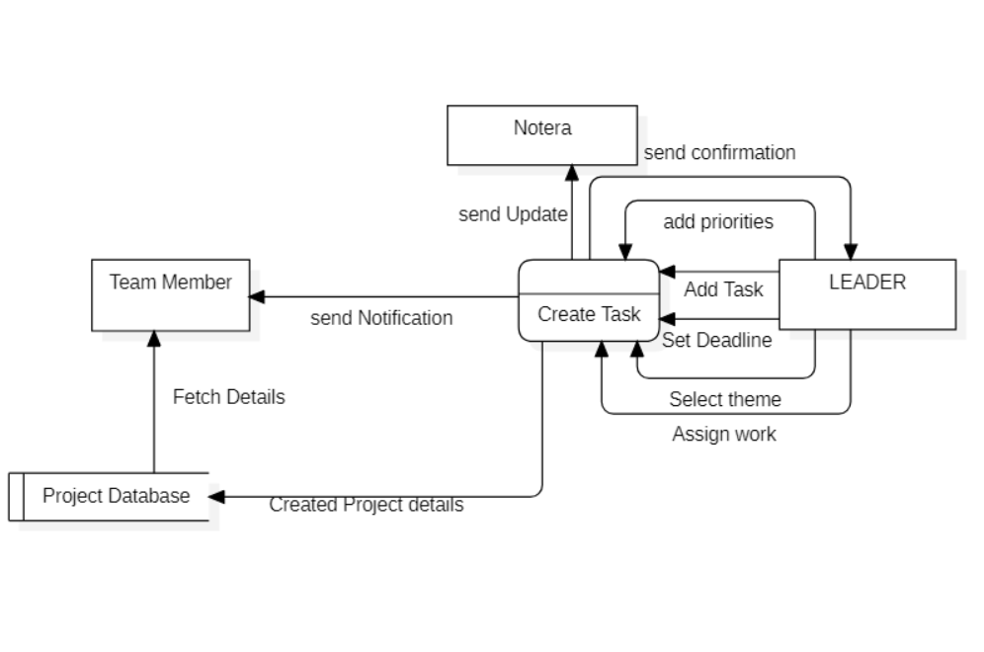

**USECASE**

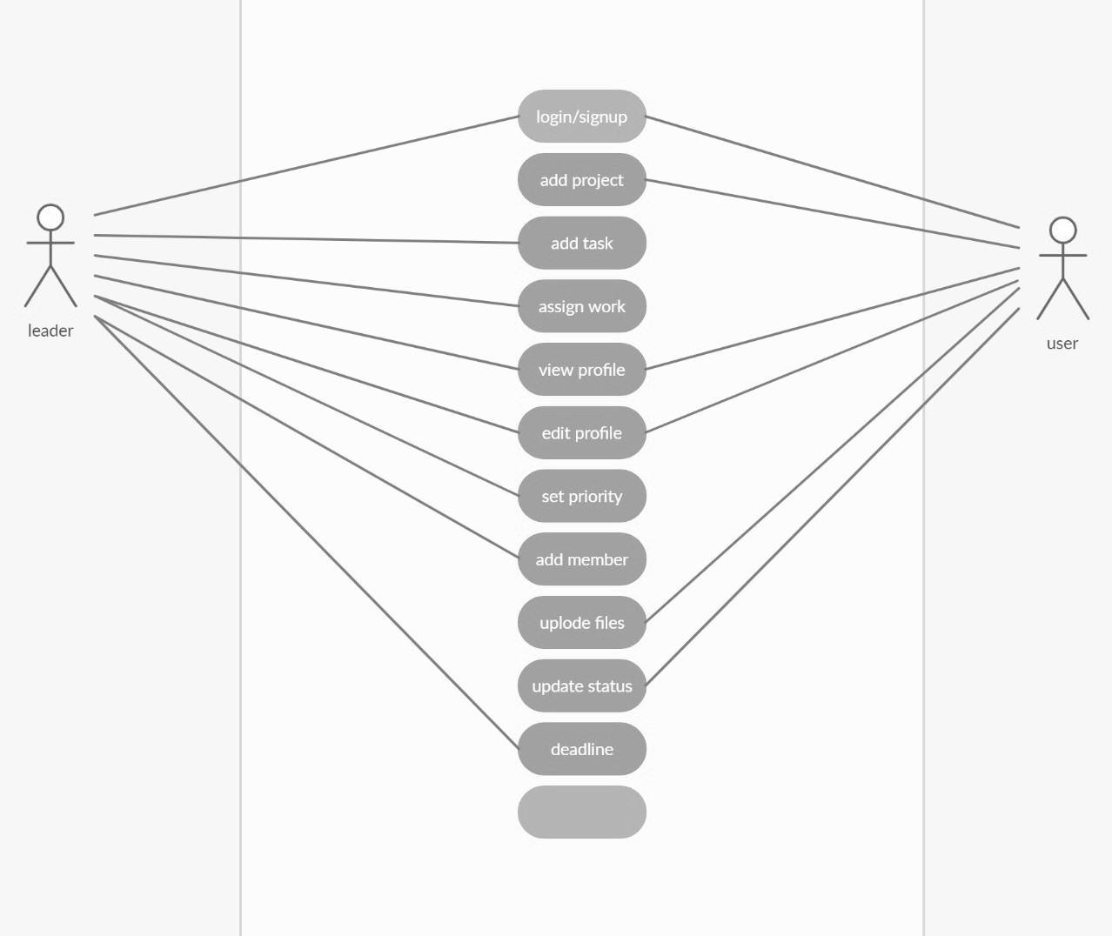

CLASS DIAGRAM

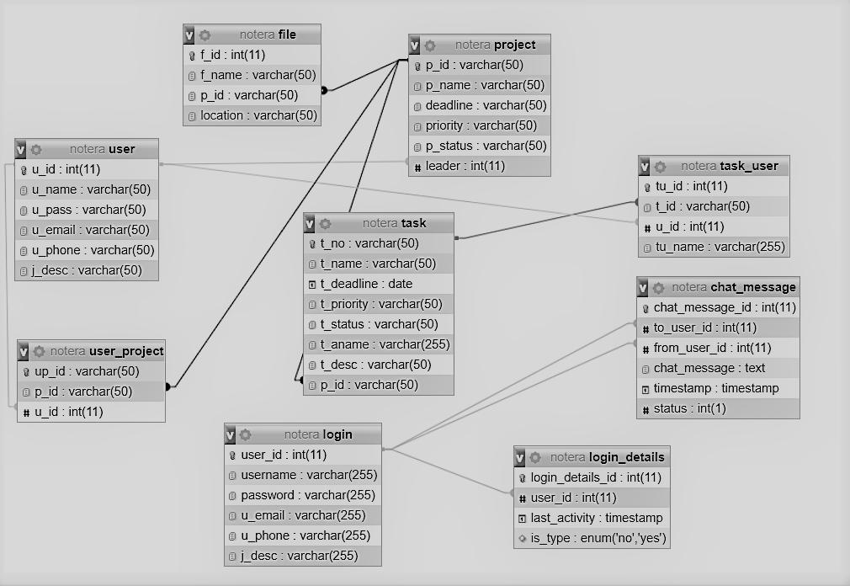

**DATABASE TABLES**

Top of Form

**Chat_message**

| **#** | **Name** | **Type** | **Collation** | **Attributes** | **Null** | **Default** | **Comments** | **Extra** |
| --- | --- | --- | --- | --- | --- | --- | --- | --- |
| 1 | **chat_message_id Primary** | int(11) |  |  | No | *None* |  | AUTO_INCREMENT |
| 2 | **to_user_id Index** | int(11) |  |  | No | *None* |  |  |
| 3 | **from_user_id Index** | int(11) |  |  | No | *None* |  |  |
| 4 | **chat_message** | text | latin1_swedish_ci |  | No | *None* |  |  |
| 5 | **timestamp** | timestamp |  |  | No | current_timestamp() |  |  |
| 6 | **status** | int(1) |  |  | No | *None* |  |  |

Bottom of Form

**File**

Top of Form

| **#** | **Name** | **Type** | **Collation** | **Attributes** | **Null** | **Default** | **Comments** | **Extra** |
| --- | --- | --- | --- | --- | --- | --- | --- | --- |
| 1 | **chat_message_id Primary** | int(11) |  |  | No | *None* |  | AUTO_INCREMENT |
| 2 | **to_user_id Index** | int(11) |  |  | No | *None* |  |  |
| 3 | **from_user_id Index** | int(11) |  |  | No | *None* |  |  |
| 4 | **chat_message** | text | latin1_swedish_ci |  | No | *None* |  |  |
| 5 | **timestamp** | timestamp |  |  | No | current_timestamp() |  |  |
| 6 | **status** | int(1) |  |  | No | *None* |  |  |

Bottom of Form

**Login**

| **#** | **Name** | **Type** | **Collation** | **Attributes** | **Null** | **Default** | **Comments** | **Extra** |
| --- | --- | --- | --- | --- | --- | --- | --- | --- |
| 1 | **user_id Primary** | int(11) |  |  | No | *None* |  | AUTO_INCREMENT |
| 2 | **username** | varchar(255) | latin1_swedish_ci |  | No | *None* |  |  |
| 3 | **password** | varchar(255) | latin1_swedish_ci |  | No | *None* |  |  |
| 4 | **u_email** | varchar(255) | latin1_swedish_ci |  | No | *None* |  |  |
| 5 | **u_phone** | varchar(255) | latin1_swedish_ci |  | No | *None* |  |  |
| 6 | **j_desc** | varchar(255) | latin1_swedish_ci |  | No | *None* |  |  |

**Login_details**

| **#** | **Name** | **Type** | **Collation** | **Attributes** | **Null** | **Default** | **Comments** | **Extra** |
| --- | --- | --- | --- | --- | --- | --- | --- | --- |
| 1 | **login_details_id Primary** | int(11) |  |  | No | *None* |  | AUTO_INCREMENT |
| 2 | **user_id Index** | int(11) |  |  | No | *None* |  |  |
| 3 | **last_activity** | timestamp |  |  | No | current_timestamp() |  |  |
| 4 | **is_type** | enum('no', 'yes') | latin1_swedish_ci |  | No | *None* |  |  |

**Project**

| **#** | **Name** | **Type** | **Collation** | **Attributes** | **Null** | **Default** | **Comments** | **Extra** |
| --- | --- | --- | --- | --- | --- | --- | --- | --- |
| 1 | **p_id Primary** | varchar(50) | latin1_swedish_ci |  | No | *None* |  |  |
| 2 | **p_name** | varchar(50) | latin1_swedish_ci |  | No | *None* |  |  |
| 3 | **deadline** | varchar(50) | latin1_swedish_ci |  | No | *None* |  |  |
| 4 | **priority** | varchar(50) | latin1_swedish_ci |  | No | *None* |  |  |
| 5 | **p_status** | varchar(50) | latin1_swedish_ci |  | No | *None* |  |  |
| 6 | **leader Index** | int(11) |  |  | Yes | *NULL* |  |  |

**Task**

| **#** | **Name** | **Type** | **Collation** | **Attributes** | **Null** | **Default** | **Comments** | **Extra** |
| --- | --- | --- | --- | --- | --- | --- | --- | --- |
| 1 | **t_no Primary** | varchar(50) | latin1_swedish_ci |  | No | *None* |  |  |
| 2 | **t_name** | varchar(50) | latin1_swedish_ci |  | Yes | *NULL* |  |  |
| 3 | **t_deadline** | date |  |  | Yes | *NULL* |  |  |
| 4 | **t_priority** | varchar(50) | latin1_swedish_ci |  | Yes | *NULL* |  |  |
| 5 | **t_status** | varchar(50) | latin1_swedish_ci |  | Yes | *NULL* |  |  |
| 6 | **t_aname** | varchar(255) | latin1_swedish_ci |  | Yes | *NULL* |  |  |
| 7 | **t_desc** | varchar(50) | latin1_swedish_ci |  | Yes | *NULL* |  |  |
| 8 | **p_id Index** | varchar(50) | latin1_swedish_ci |  | Yes | *NULL* |  |  |

**User**

| **#** | **Name** | **Type** | **Collation** | **Attributes** | **Null** | **Default** | **Comments** | **Extra** |
| --- | --- | --- | --- | --- | --- | --- | --- | --- |
| 1 | **u_id Primary** | int(11) |  |  | No | *None* |  | AUTO_INCREMENT |
| 2 | **u_name** | varchar(50) | latin1_swedish_ci |  | No | *None* |  |  |
| 3 | **u_pass** | varchar(50) | latin1_swedish_ci |  | No | *None* |  |  |
| 4 | **u_email** | varchar(50) | latin1_swedish_ci |  | No | *None* |  |  |
| 5 | **u_phone** | varchar(50) | latin1_swedish_ci |  | No | *None* |  |  |
| 6 | **j_desc** | varchar(50) | latin1_swedish_ci |  | Yes | *NULL* |  |  |

**User_project**

|  |
| --- |
|  |
| **#** | **Name** | **Type** | **Collation** | **Attributes** | **Null** | **Default** | **Comments** | **Extra** |
| 1 | **up_id Primary** | varchar(50) | latin1_swedish_ci |  | No | *None* |  |  |
| 2 | **p_id Index** | varchar(50) | latin1_swedish_ci |  | Yes | *NULL* |  |  |
| 3 | **u_id Index** | int(11) |  |  | Yes | *NULL* |  |  |

# Modules screenshot:

**HOME PAGE**

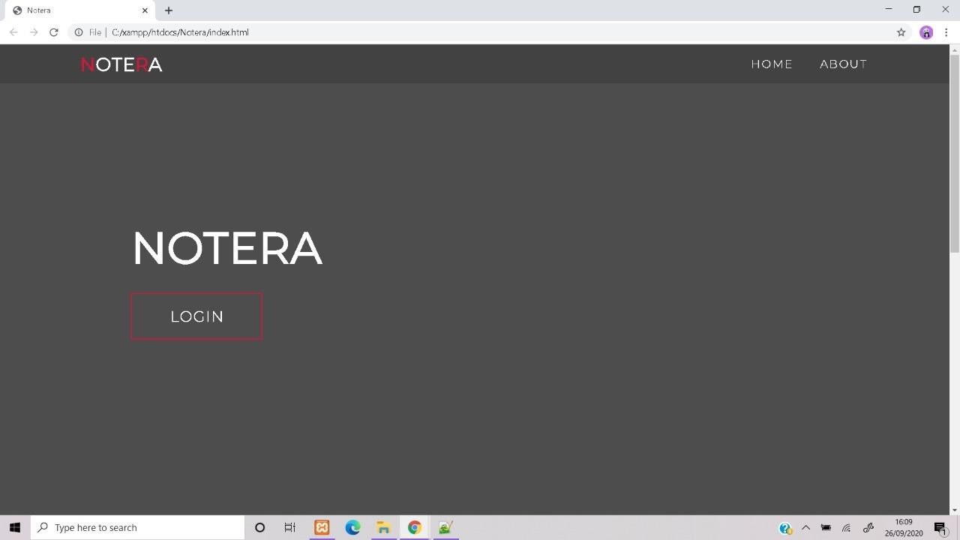

ABOUT PAGE

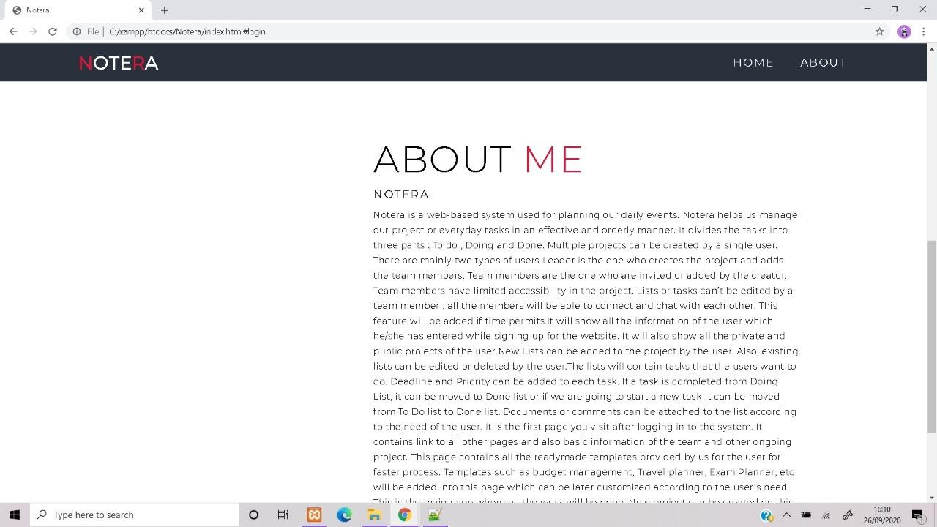

**PROFILE**

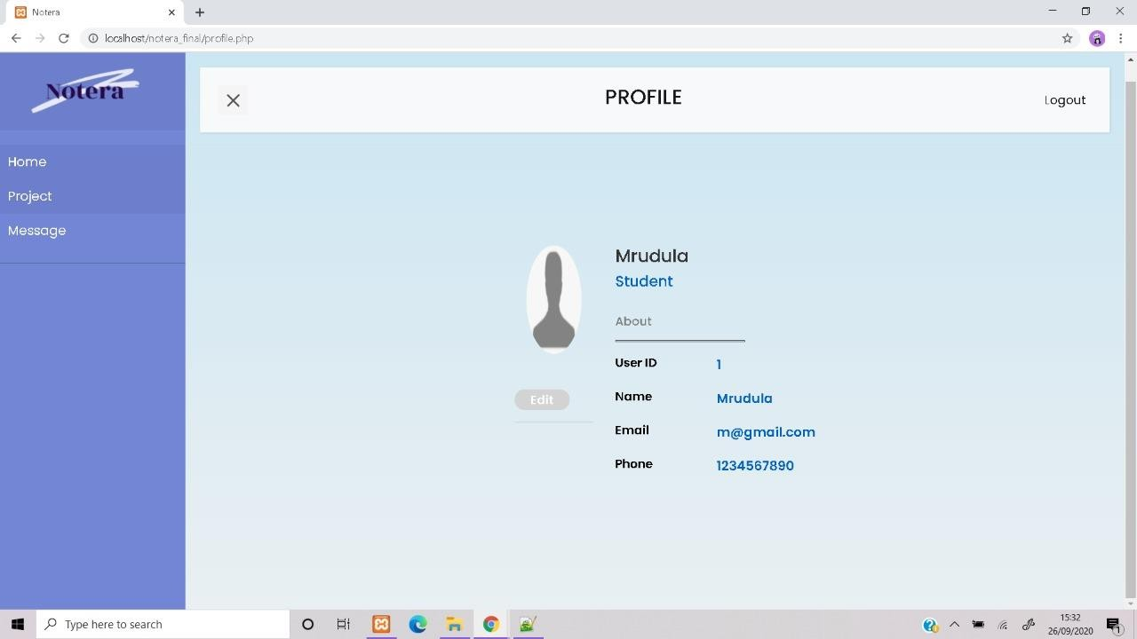

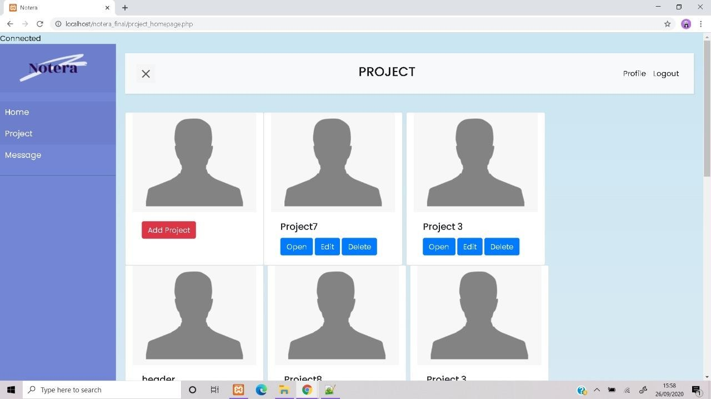**PROJECT HOMEPAGE:**

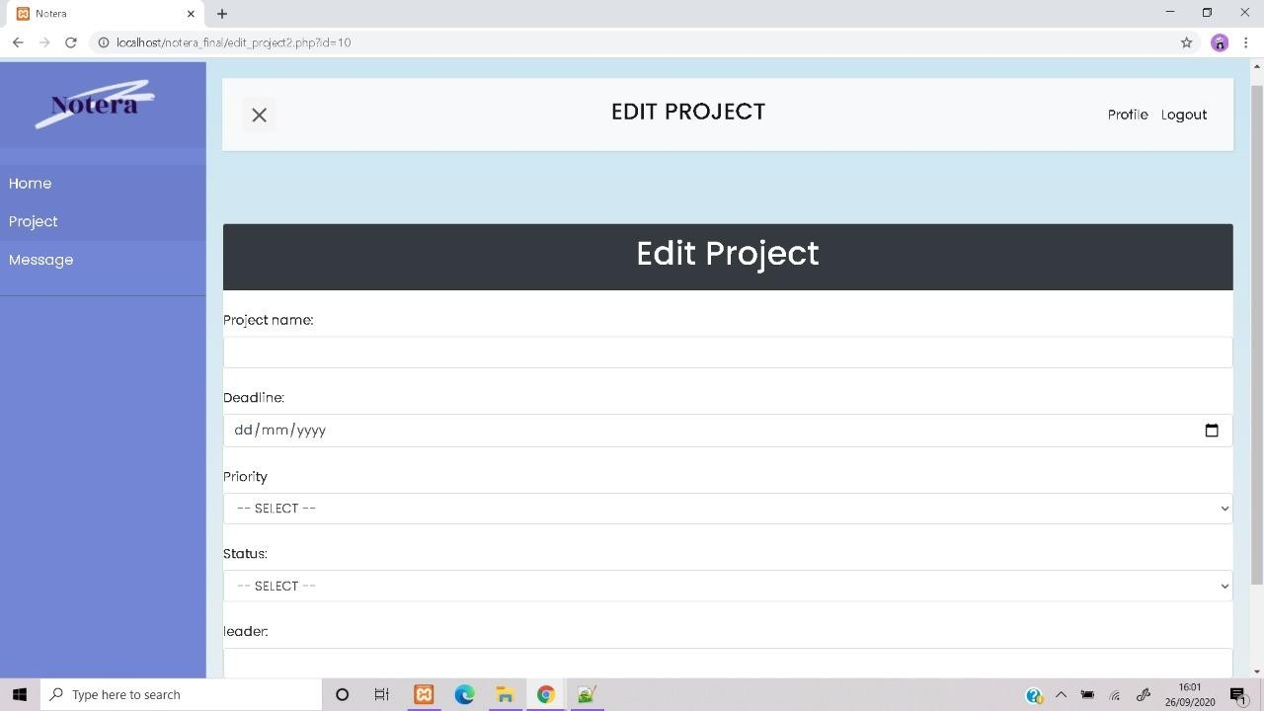**ADD PROJECT**

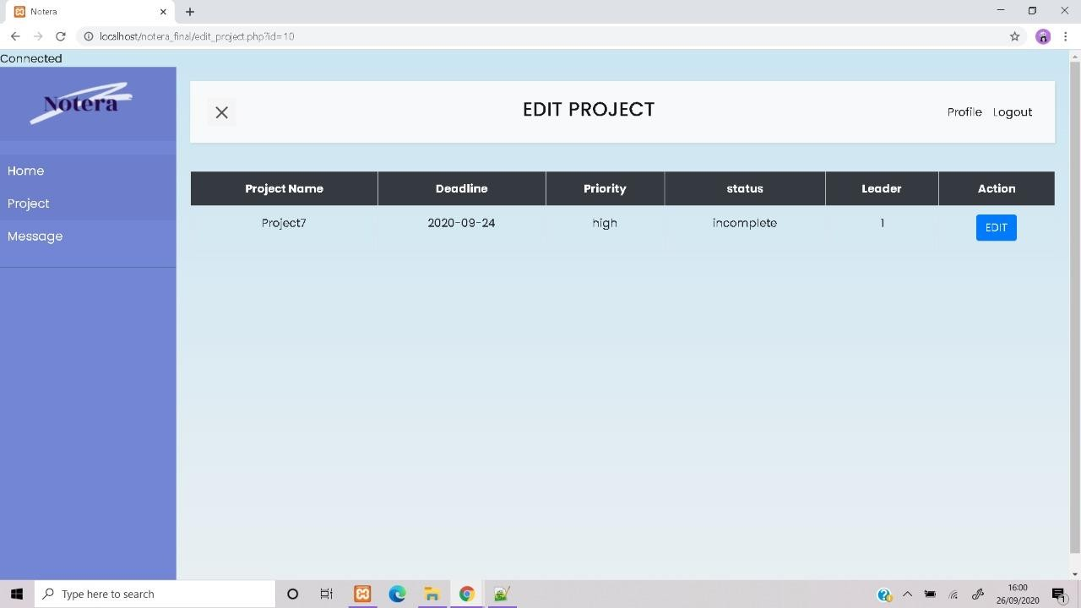**EDIT PROJECT**

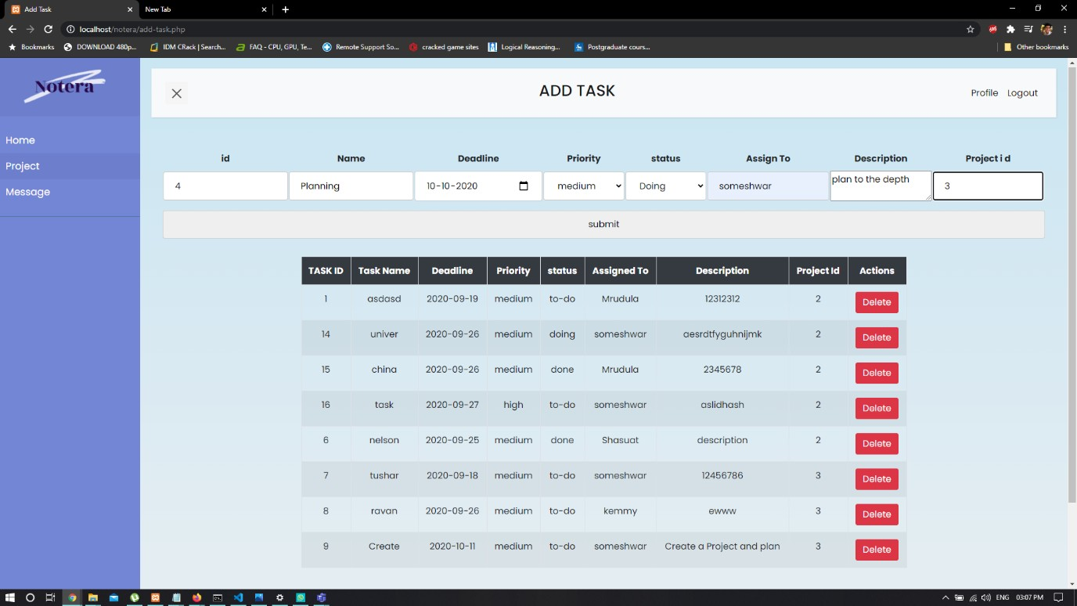**ADDING TASK**

**ADDED TASK**

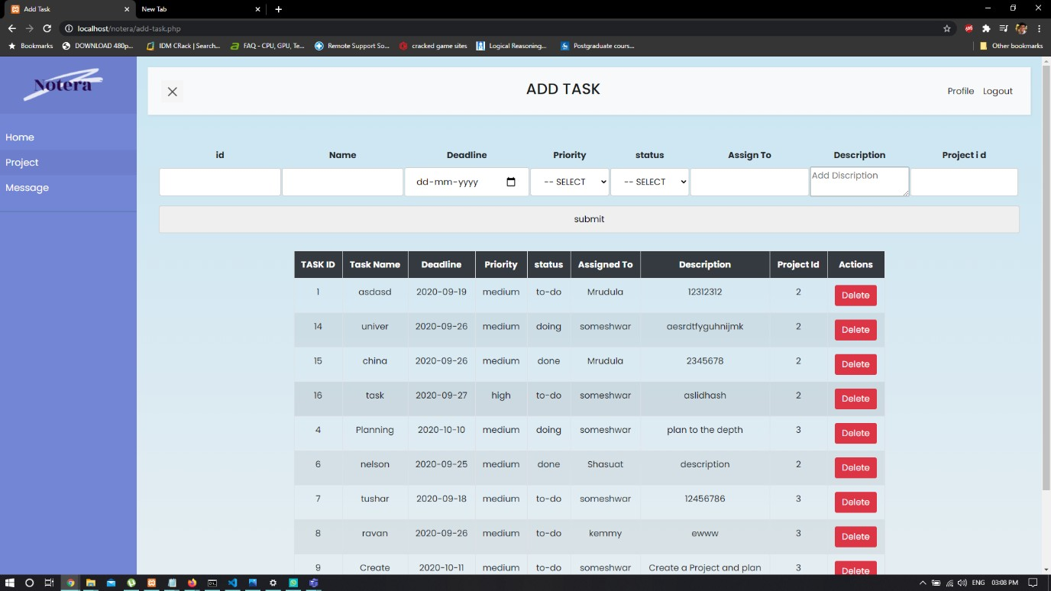

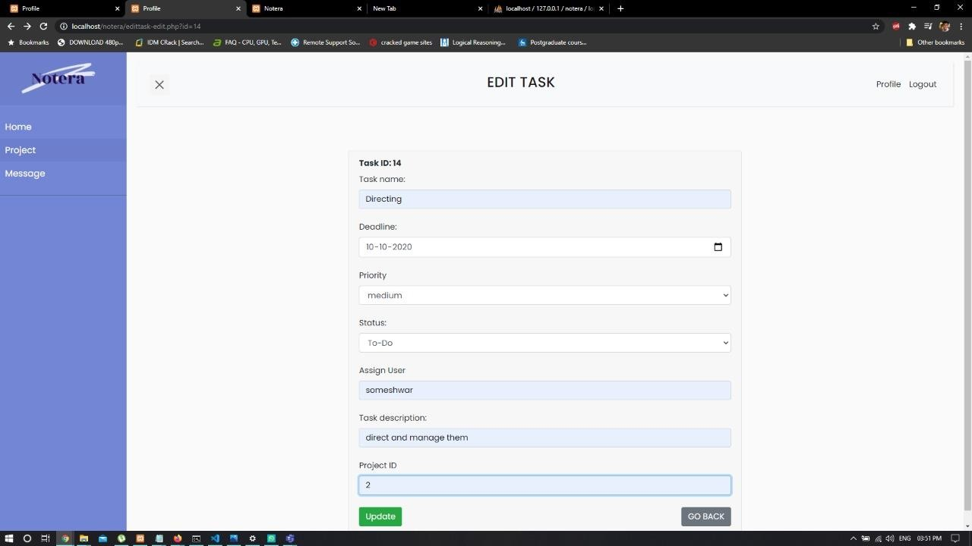EDIT TASK

**PROJECT HOMEPAGE**



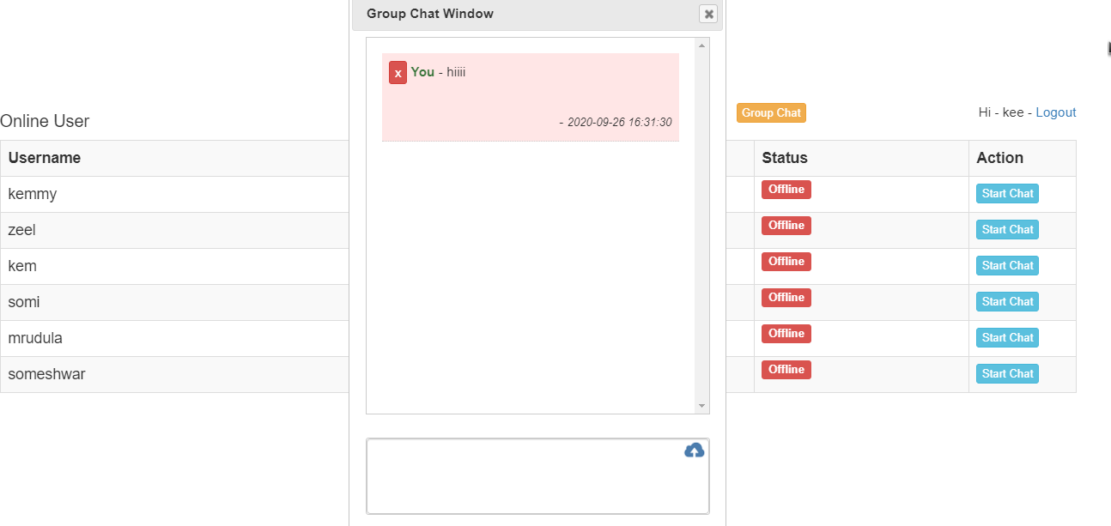**CHAT PAGE**

**SHOWING USERS**

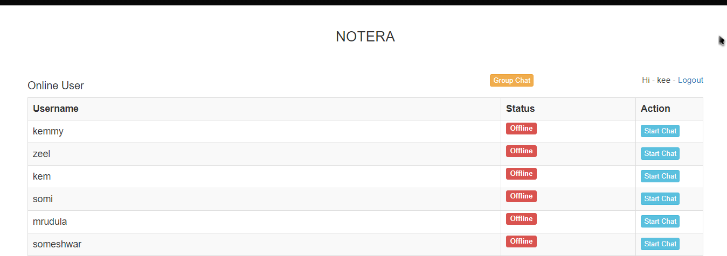

**Test Cases**

**Login_Details**

|  |  |  |  |
| --- | --- | --- | --- |
| **login_details_id** | **user_id** | **last_activity** | **is_type** |
| **0** | 2 | 26-09-2020 22:45 | no |
| **0** | 2 | 26-09-2020 22:45 | no |
| **0** | 2 | 26-09-2020 22:45 | no |
| **0** | 1 | 26-09-2020 22:45 | no |
| **0** | 2 | 26-09-2020 22:45 | no |
| **0** | 3 | 26-09-2020 22:45 | no |
| **0** | 1 | 26-09-2020 22:45 | no |
| **0** | 1 | 26-09-2020 22:45 | no |
| **0** | 1 | 26-09-2020 22:45 | no |
| **0** | 1 | 26-09-2020 22:45 | no |
| **0** | 1 | 26-09-2020 22:45 | no |
| **0** | 1 | 26-09-2020 22:45 | no |
| **0** | 1 | 26-09-2020 22:45 | no |
| **0** | 1 | 26-09-2020 22:45 | no |
| **0** | 1 | 26-09-2020 22:45 | no |
| **0** | 1 | 26-09-2020 22:45 | no |
| **0** | 2 | 26-09-2020 22:45 | no |
| **0** | 2 | 26-09-2020 22:45 | no |
| **0** | 2 | 26-09-2020 22:45 | no |
| **0** | 4 | 26-09-2020 22:45 | no |
| **0** | 2 | 26-09-2020 22:45 | no |
| **0** | 2 | 26-09-2020 22:45 | no |
| **0** | 2 | 26-09-2020 22:45 | no |
| **0** | 2 | 26-09-2020 22:45 | no |
| **0** | 2 | 26-09-2020 22:45 | no |
| **0** | 2 | 26-09-2020 22:45 | no |
| **0** | 2 | 26-09-2020 22:45 | no |
| **0** | 3 | 26-09-2020 22:45 | no |
| **0** | 2 | 26-09-2020 22:45 | no |
| **0** | 1 | 26-09-2020 23:28 | no |
| **0** | 2 | 26-09-2020 23:51 | no |

**Login Table**

|  |  |  |  |  |  |
| --- | --- | --- | --- | --- | --- |
| **user_i**  **d** | **usernam**  **e** | **password** | **u_email** | **u_phone** | **j_desc** |
| **1** | mrudula | $2y$10$24ABadGM7/a/ | [m@gmail.co](mailto:m@gmail.co)  m | 798645132  0 | student |
| **2** | someshw  ar | $2y$10$EmUUcwP3pad4f// | [ss@gmail.co](mailto:ss@gmail.co)  m | 123456798 | programm  er |
| **3** | Kemmy | $2y$10$O/7nTKXGsMJKp0N93bqc/.  14Vasja | [k@gmail.com](mailto:k@gmail.com) | 465132098  7 | director |
| **4** | shasuat | $2y$10$gULe7qDv8.VkV/ | [st@gmail.co](mailto:st@gmail.co)  m | 846519888  79 | ceo |

**Chat_message Table**

|  |  |  |  |  |  |
| --- | --- | --- | --- | --- | --- |
| **chat_message_id** | **to_user_id** | **from_user_id** | **chat_message** | **timestamp** | **status** |
| **1** | 3 | 2 | heyy | 26-09-2020 18:37 | 0 |
| **2** | 1 | 2 | how are you  doing? ? | 27-09-2020 12:00 | 1 |
| **3** | 2 | 3 | asdas | 27-09-2020 12:07 | 0 |
| **4** | 3 | 2 | how are you | 27-09-2020 12:07 | 0 |

**File Table**

|  |  |  |  |
| --- | --- | --- | --- |
| **f_id** | f_name | p_id | location |
| **1** | 12asd3 | 2 | dxfcvgjhbkjn |
| **2** | jajaj | 2 | gvhbnkjml |
| **3** | lalal | 2 | C:xampp mpphpE343.tmp |
| **4** | ideas.txt | 2 | C:xampp mpphp6BCD.tmp |

**Task Table**

|  |  |  |  |  |  |  |  |
| --- | --- | --- | --- | --- | --- | --- | --- |
| **t_no** | **t_name** | **t_deadline** | **t_priority** | **t_status** | **t_aname** | **t_desc** | **p_id** |
| **1** | asdasd | 19-09-  2020 | medium | doing | Mrudula | 12312312 | 2 |
| **10** | stafing | 29-09-  2020 | low | done | someshwar | staff the members | 2 |
| **11** | editing | 11-10-  2020 | high | doing | Mrudula | edit the data | 2 |
| **12** | reviewing | 10-10-  2020 | medium | to-do | Mrudula | plan to the depth | 2 |
| **13** | posting | 27-12-  2021 | medium | to-do | kemmy | delete the task | 2 |
| **14** | Directing | 10-10-  2020 | medium | to-do | Mrudula | direct and manage  them | 2 |
| **15** | china | 26-09-  2020 | medium | done | Mrudula | 2345678 | 2 |
| **16** | task | 27-09-  2020 | high | doing | someshwar | aslidhash | 2 |
| **2** | adding | 12-10-  2020 | high | to-do | someshwar | add data | 2 |
| **3** | editing | 11-10-  2020 | medium | doing | someshwar | edit the data | 2 |
| **4** | Planning | 10-10-  2020 | medium | done | Kemmy | plan to the depth | 2 |
| **5** | deleting | 27-12-  2021 | medium | to-do | someshwar | delete the task | 2 |
| **6** | nelson | 25-09-  2020 | medium | doing | someshwar | description | 2 |
| **7** | tushar | 18-09-  2020 | medium | to-do | shasuat | 12456786 | 2 |
| **9** | Create | 11-10-  2020 | medium | doing | shasuat | Create a Project  and plan | 2 |

**Project Table**

|  |  |  |  |  |  |
| --- | --- | --- | --- | --- | --- |
| **p_id** | **p_name** | **deadline** | **priority** | **p_status** | **leader** |
| **2** | tesla | 08-10-2019 | medium | incomplete | 1 |
| **3** | kiaaa | 24-09-2020 | high | incomplete | 1 |

**LIMITATIONS OF EXISTING SYSTEM**

* Lack of security of data.
* Time consuming.
* Consumes large volume of paper work.
* Manual work
* Reporting Work
* Backups

To avoid all these limitations and make the system working more accurately it needs to be computerized.

## CONCLUSION

Goals like ordering out daily tasks, and better time management has been successfully achieved with the help of this project. With the help of this project we can create new projects, add new tasks, chat with other members, share files and photos and so on.

## BIBLIOGRAPHY

## https://www.w3schools.com/

## https://www.w3schools.com/

## https://creately.com/

## https://www.apachefriends.org/index.html/

## https://www.phptpoint.com/php-tutorial/